1.SET UP AND CREATE A GIT REPOSITORY

Generating files and initializing the.git directory

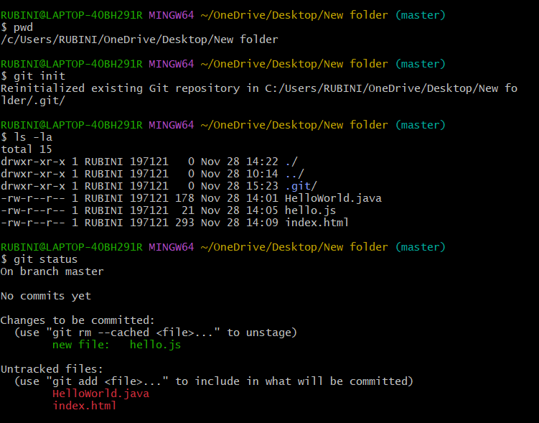

Executing the basic commands

